**Call Data Record - Inter Operator Settlement**

**Scope**

This document specifies charging functionality and charging management for cellular service providers. Specifically, this document describes the handling of CDR files that contain CDR records. Each CDR record contains descriptions of charging events such as voice calls and SMS messages with all relevant data.

**Offline Charging**

Offline charging is a process where charging information for network resource usage is collected concurrently with that resource usage. The charging information is then passed through a chain of logical charging functions. At the end of this process, CDR files are generated by the network, which are then transferred to the network operator’s BD (Billing domain) for the purpose of subscriber billing and inter-operator accounting.

**CDR Flow Diagram**

The CDR files contain a header section followed by a variable sized CDR data section. The CDR data section contains zero or more concatenated CDR records. Each CDR record is encoded on a single line.

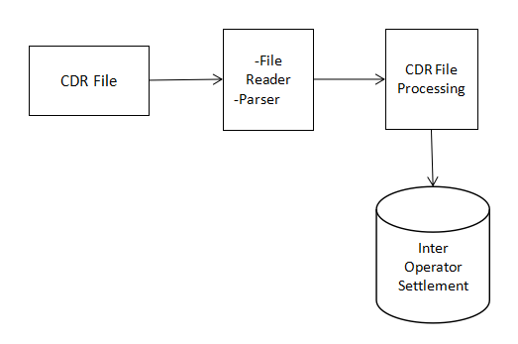

**Processing Functions**

The CDR files are usually large files (1-5 MB). Processor will read and process files in order to fulfil the following functions

1. **Functional Requirements**

**[CDR-IOS]/01 -** Signup

**[CDR-IOS]/02 -** Login

**[CDR-IOS]/03 -** Create client -server connection

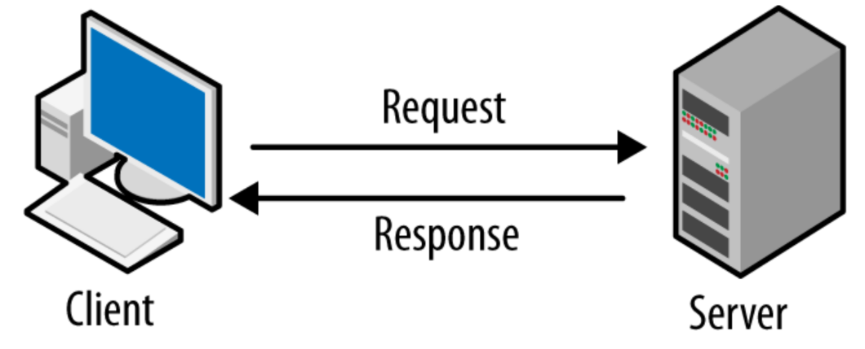

**[CDR-IOS]/04 -** Client have to send a request to server to get CDR file which is stored in directory and store the processed data in STL container.

**[CDR-IOS]/05 - MSISDN:**

Unique number identifying a subscription in a mobile network maximum length of an MSISDN to 7 digits.

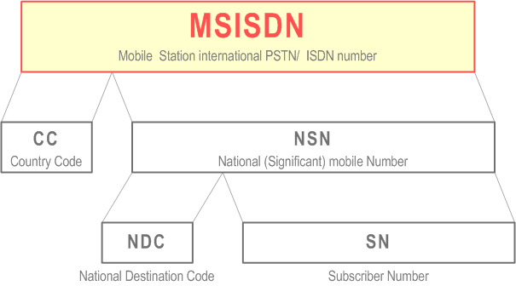

**[CDR-IOS]/06 - Brand Name:**

Subscriber Brand Name: a string maximum 64 chars. Such as “Airtel”.

**[CDR-IOS]/07 - MMC/MNC:**

Subscriber MMC/MNC: mobile country code and mobile network code maximum 6 digits.

**[CDR-IOS]/08 - MOC: Outgoing Voice Call**

* Inter Operator Settlement contains information about “Outgoing voice calls duration to a subscriber within the mobile operator.”

**Ex:** Airtel is the Mobile operator for the person who called and who receives that call. We have to note the duration of that outgoing call.

* Inter Operator Settlement contains information about “Outgoing voice calls duration to a subscriber outside the mobile operator.”

**Ex:** Airtel is the Mobile operator for the person who called and Idea is the Mobile operator who receives that call. We have to note the duration of that outgoing call.

**[CDR-IOS]/09 - MTC: Incoming Voice Call**

* Inter Operator Settlement contains information about “Incoming voice calls duration to a subscriber within the mobile operator.”

**Ex:** Airtel is the Mobile operator for the person who called and who receives that call. We have to note the duration of that incoming call.

* Inter Operator Settlement contains information about “Outgoing voice calls duration to a subscriber outside the mobile operator.”

**Ex:** Airtel is the Mobile operator for the person who called and Idea is the Mobile operator who receives that call. We have to note the duration of that incoming call.

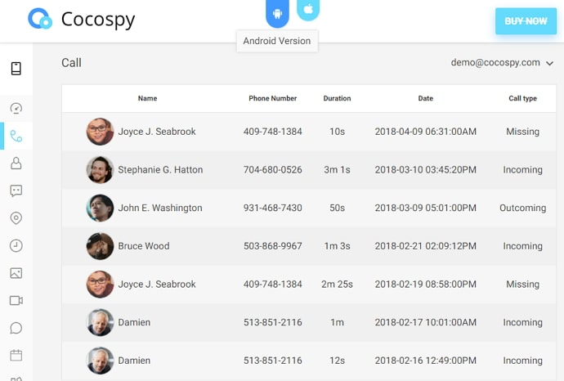

**[CDR-IOS]/10 - SMS-MO: Outgoing Message**

* Inter Operator Settlement contains information about “SMS messages sent within the mobile operator.”

**Ex:** Subscriber with Airtel mobile operator sent message to the the subscriber of Airtel mobile operator itself. We have to know the source and destination phone numbers.

* Inter Operator Settlement contains information about “SMS messages sent outside the mobile operator.”

**Ex:** Subscriber with Airtel mobile operator sent message to the the subscriber of BSNL mobile operator. We have to know the source and destination phone numbers.



**[CDR-IOS]/11 - SMS-MT: Incoming Message**

* Inter Operator Settlement contains information about “SMS messages received within the mobile operator.”

**Ex:** Subscriber with Airtel mobile operator receives message from the subscriber of Airtel mobile operator itself. We have to know the source and destination phone numbers.

* Inter Operator Settlement contains information about “SMS messages received outside the mobile operator.”

**Ex:** Subscriber with Airtel mobile operator receives message from the subscriber of BSNL mobile operator. We have to know the source and destination phone numbers.



**[CDR-IOS]/12 - Download: MB downloaded if call type is GPRS**

* Inter Operator Settlement contains information about “MB downloaded.”

**Ex:** If you have downloaded anything from browser, or received any files from any other sources, then we have to note that how much data had been used to download those files.

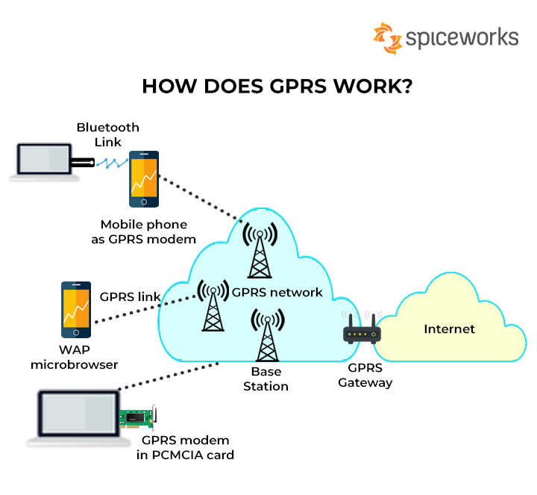

**[CDR-IOS]/13 - Upload: MB uploaded if call type is GPRS**

* Inter Operator Settlement contains information about “MB uploaded.”

**Ex:** If you have uploaded anything to drive, or shared any files to any other sources like whatsapp or gmail, then we have to note that how much data had been used to upload those files.

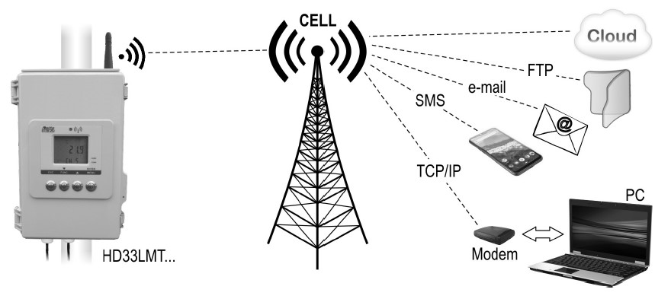

**[CDR-IOS]/14 - Third party MSISDN:**

* Corresponding third party in this call, empty for GPRS

**[CDR-IOS]/15 - Third party Subscriber MMC/MNC:**

* Corresponding third party’s mobile subscriber in this call.

**[CDR-IOS]/16 -** If CDR file is not present then display proper message in client side.

**[CDR-IOS]/17 -** Get total call duration, SMS within and outside for all clients and total download /upload data

**[CDR-IOS]/18 -** After the client exits from the server, the generated output should be moved to the file.

**[CDR-IOS]/19 -** Search for particular client (subscriber) using client id(country code) to get the complete result on to the screen

**[CDR-IOS]/20-** Using the data in STL container get the result only for that id (country cod), if present else display proper message.

**[CDR-IOS]/21-** Search for a particular client id(country code) for particular set of information i.e get total SMS sent/received, incoming/outgoing calls within mobile operator/outside mobile operator and total data download/upload. Then disconnect with server.

1. **Non-Functional Requirements**

## **2.1 Performance Requirements**

The mobile will require a fair network/signal connection to receive call/SMS or to transfer files and to make call/SMS or to receive files.

## **2.2 Safety Requirements**

Call recordings must be stored securely and businesses should ensure proper access controls are in place. There should be physical and technical safeguards for data security and privacy. You should assess the risks associated with hackers, malicious insiders, and even careless employees and take measures accordingly.

## **2.3 Security Requirements**

The Call Data Record itself does not provide authentication and security. We have to provide authentication to access this files. We have to secure the data in file.

**Ex: Data.cdr**

1037928|Rami levi|42502|SMS-MT|0|0|0|1136404|42504

1513251|Rami levi|42502|MOC|135|0|0|1686214|42502

1215082|Rami levi|42502|MTC|116|0|0|1266690|42503

1497537|Partner|42501|SMS-MO|0|0|0|1879213|42501

1800253|Partner|42501|GPRS|0|0|337||42504

**Output**

Operator Brand: Rama levi (42502)

Incoming voice call duration:116

Outgoing voice call duration:135

Incoming Messages:1

Outgoing Messages:0

MB downloaded: 0 | MB uploaded: 0

Operator Brand: Partner (42501)

Incoming voice call duration:0

Outgoing voice call duration:0

Incoming Messages:0

Outgoing Messages:1

MB downloaded: 0 | MB uploaded: 337